**Harvie PR Client Report**

Adam Kelly

Maria Ciarrocca

Maddie Wateska

Meng Chen

**Executive Summary**

This report will focus on expanding Harvie’s customer base to millennials living within the Pittsburgh area. It will offer an in-depth analysis of Harvie’s current digital media presence and strategies, as well as recommendations on how to improve current public relations infrastructure to increase effectiveness and exposure. Initial recommendations will focus on recognizing the client’s website to make the service that Harvie is providing clearer to the customer. The bulk of the report will focus on how to broaden exposure and encourage potential customers to use Harvie. Those recommendations will come in 2 forms: social media that provides recipes and cultivates an online following, physical media in the form of flyers and promotional items that increase brand awareness and lead customers to the digital media.

**Company Profile**

**Mission :** The mission of Harvie is to connect farmers with potential customers while expanding the concept of farm share in urban areas. Harvie intends to help you eat more healthy, local food while also helping you learn how to cook with all fresh ingredients. The ability to customize your box and decide which ingredients you want and don’t want aids in Harvie achieving their goal to reduce food waste. Harvie wants to grow their customer base while retaining their current customers’ participation in Community-Shared Agriculture.

**Key Stakeholders :**

* Farmers
* Potential Consumers
* Small Farm Central

**Industry :** Harvie exists in a growing industry of fresh-produce delivery. Instead of going to the supermarket or a local farm market, consumers are now able to receive fresh ingredients on a weekly or monthly basis in box tailored to their palette. Most of these services feature websites that allow the consumer to rate the produce and decide what he or she would like to see in the next box. Harvie stands out by adding the benefit of knowing exactly where the produce is coming from by connecting you with a local farm. Harvie provides farmers with the ability to keep up with the latest trends in meal delivery by making sure local farms still find a way to get their crops to customers. In simple terms, Harvie helps keep local farms competitive.

**Main competitors ：**

* Supermarket
* Whole Amazon
* HelloFresh
* Blue Apron
* Local Farmer’s Markets

**Communication Audit**

**Website :**

Harvie’s website design is sleek, modern, and easy to navigate. However, the information itself isn’t organized in a way that makes their service and mission clear to its stakeholders. In other words, the website could use better organizing.

The first thing that a customer sees on the website should be the “What is Harvie” blurb followed by “The Harvie Process” infographic that are currently further down on the homepage. Customers should also be aware of the “Customize your box” feature in a more visible portion of your homepage, as that interactivity and customization is perhaps the most enticing and marketable element of Harvie to the target demographic. Featured farms and Our farmers could be at bottom of the homepage or in the “Farms” section of navigation bar but change name of “Farms” section to “Find your perfect farm.” The site should also include a new table on the navigation bar for “Recipes”, and the headline of that landing page could be “Fresh Ingredients can make anyone look like a chef.”

Visually, the website presentation is strong, and the diagram that features “The Harvie Process” is also quite effective in explaining how Harvie works. These recommendations on reorganization should help the communication become clearer. Right now, the messaging on the website is unclear because of this lack of organization.

**External Articles :**

Harvie’s website contains links to articles written by the client that explain the concept of community-shared agriculture. These articles, which are targeted primarily for the farmers that use Harvie’s services, provide a concise definition of community-shared agriculture, as well as helpful statistics that describe the state of community-shared agriculture in terms of how many people are using it in various areas. The text of this article might be helpful to include somewhere on the website to help customers that are purchasing the produce better understand the importance of buying from local farms. This could give the customers a sense of responsibility to be an advocate for local farming by purchasing produce grown in their area.

**Social Media :**

In terms of presence on social media, Harvie has an Instagram account. This account features pictures with text quotes, infographics, and personal photos of the client with his family. Much like the website, a majority of the content is professionally made with clear messaging and visuals. However, some of the content is is messaged for the farmers, while other pieces of the content are messaged for the customers buying the produce. This lack of consistency may be driving customers away that are unsure about exactly who Harvie is targeting. In addition, pictures of the client and his family on the website can also distract potential customers from the primary message of Harvie. The best course of action would be separate Instagram pages for customers and for farmers.

Other than Instagram, Harvie lacks a social media presence, which is vital in getting messages out to the target demographic. Facebook is an area where there is room for growth for Harvie. The Facebook page can link directly with Instagram to help share content to a wider audience. Facebook can also be helpful in advertising events in target areas and notifying customers of pickup times and locations for produce.

Improvement of social media communication is the foundation for growing Harvie, as 68 percent of U.S. adults are Facebook users, with about three quarters of these users claiming to use Facebook daily . In addition, Instagram is the most effective way to target a younger audience, with 35 percent of U.S. adults using Instagram, 71 percent of those age 18-24 use Instagram (Pew Research).

**Conclusion of Findings:**

Harvie’s external communication is visually appealing and captures the attention of the user, however the messaging needs better organization. The first step in achieving a clear message is to more thoroughly separate the messaging based on the target audience. When a user lands on a page, whether it be the website or the Instagram, it should feel as though Harvie is speaking directly to them. On all pieces of communication, Harvie should make it clear that it is either “For Farmers” or “For Customers” and clearly articulate the benefits of Harvie to that audience. With that in mind, Harvie will be able to expand its media presence and generate more effective means of communication.

**Recommendation Statement**

Harvie aims to expand its customer base to millennials and will be in competition with such home delivery food services as HelloFresh and Blue Apron. This expansion begins with increasing awareness of what Harvie can provide to this demographic. In order to appeal to Pittsburgh’s college students and young professionals, Harvie should promote themselves through digital media initiatives along with promotional items that encourage customer participation and loyalty. Through targeted advertising placement at locations that millennials frequent, potential customers will be encouraged to visit online platforms and use Harvie’s services at an initial discount. Harvie can build an online following with a greater focus on its target audience and achieve continued exposure through advertising in local neighborhoods.

**Social Media PR Plan Discussion**

**Objective: Increase awareness by 40% of 20-30 year-olds by 1 year.**

There are many competitors in the business of fresh produce delivery boxes who are more well-known names such as Hello Fresh and Blue Apron. There is a need to gain awareness of who their company is and spreading awareness of who they are. Of Pittsburgh’s 303,000 residents, 37.6 percent of them are between ages 18-34 (NeighborhoodScout). This is a substantial target audience for Harvie to gain exposure. In doing this, Harvie could grow their customer base and also gain customer retention.

**Strategy: Further develop social media presence and messaging through improving Instagram interactivity with customers and further promotion of farm-fresh ingredients.**

**Instagram :**

The client can better organize it’s Instagram messaging in multiple ways. Harvie should have separate Instagram pages for farmers and for customers. The Instagram for customers should be curated in a way that makes Harvie desirable to customers. One way to do this is through recipes. Millennials aren’t known for their cooking, but when they do, they are using their laptop or smartphone as a kitchen tool. In fact, 93.2% of millennials claim to get their cooking recipes from the internet (Porch). Harvie can provide customers with both farm-fresh ingredients and simple recipe suggestions to help them become skilled cooks.

The United States Potato Board (USPB) had a 2011 ad campaign entitled “Seven Days and Seven Ways” which featured a calendar with a potato-centric recipe for every day of the week (Swann, 323). Harvie could create a variation of this, showcasing a prepared dish made with fresh, local-farm ingredients with the recipe in the description. Harvie could have a different recipe for each day of the week and match a food with a a day of the week (Ex. Monday recipes with greens, Tuesday for recipes with peppers).

The client should create a hashtag, such as “#myharvie” to allow Instagram users to share their ingredients and meals. Harvie can repost these to their Instagram site. If someone’s picture gets reposted, thy can get a discount on their next box. This is a way in which the customers could create content for Harvie, while establishing a digital interactive community. This idea could be integrated with the recipe calendar, and they could post the best recipe of the day or the week.

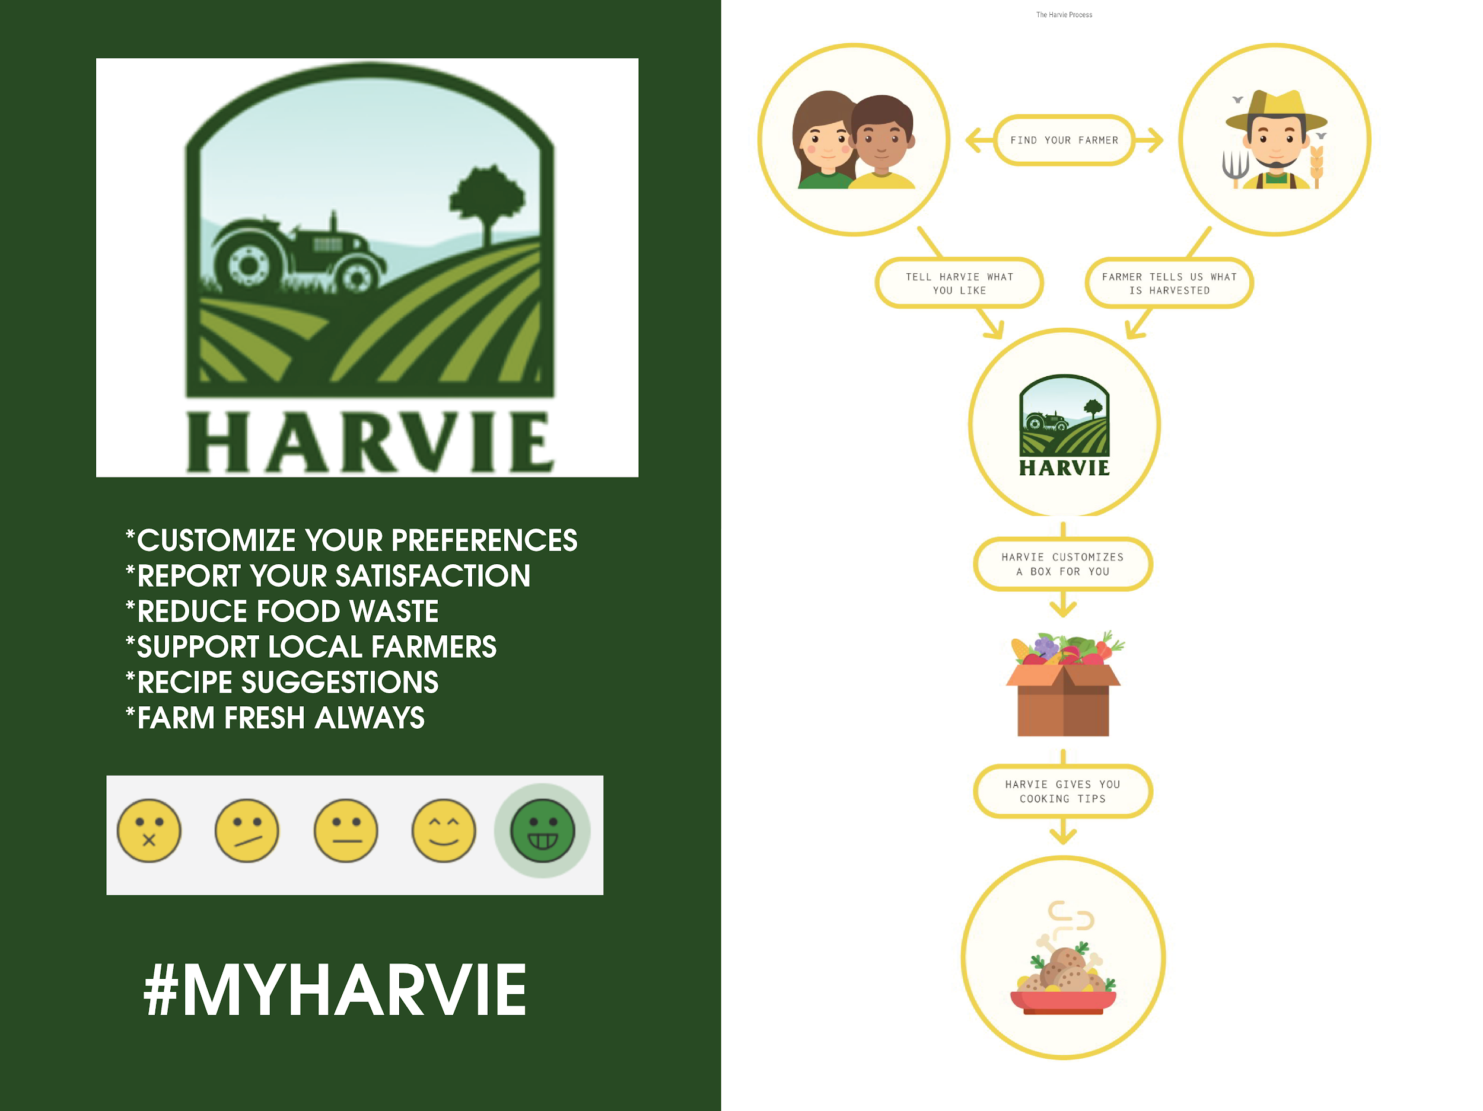

**Customer Receives Promotional Item:**

When a customer receives their first box of full of fresh produce, Harvie should include a flat magnet with their name and their hashtag “#myharvie” and a graphic that catches the eye. This magnet could also contain the tagline that Simon referenced in the initial meeting: “With fresh ingredients, anyone can look like a chef”. The hashtag that is on the magnet can be used when the customer receives their box or uses their produce to make a recipe. When the customer posts a recipe, this could be reposted by Harvie and the recipe could be used by Harvie’s other followers as well. With these magnets, the customer could place this mindlessly on their fridge and when they have guests over this could spark conversation when someone sees the magnet. This is another simple example of free advertising that does not require much coming from Harvie’s end.

**Strategy: Use planned, targeted print advertising to increase awareness for Harvie and drive traffic to Harvie’s digital media platforms.**

**Promotional Codes:**

A strategy that would help Harvie reach millennials would be offering promotional codes. According to *Bigcommerce*, “When a store issues promotional codes, they're providing customers with an incentive to buy, which benefits both the customer and the business” (What are Promo Codes). Consumers love to feel like they are getting a good deal, and when a company offers promotional codes, it motivates that consumer to follow through with the order. In producing promotional codes, this is an effective way to, “track your marketing efforts to see which platforms are generating the most traffic or leading to conversions” (What are Promo Codes). This data can be helpful in finding out where the most traffic is coming from by tracking the entry and use of the promo codes and where they are shipping their order to. These codes also have the potential to be spread around via social media and easily copied and shared. This could increase Harvie’s customer base and also circulate their name around social media via free advertising. Although it may seem like such a simple concept, studies show that, “...women who received coupons during the study had significantly higher levels of oxytocin. This marked response is higher than levels associated with kissing, cuddling and other social interactions related to this hormone that is known to be associated with happiness” (MediaPost). A clear and straight to the point concept as simple as a promotional code increases happiness in buyers and is something that would not take much coming from Harvie’s end that could increase their customer base and increase customer retention by returning to the website if satisfied with their first order. These promotional codes could have many effects. This promotional code could be used on the customer’s first order, or a personalized promotional code could be given in their box that could be shared with someone else so the user benefits, and the other person that uses the promo code benefits as well. The result of this is gaining another customer as well, and a satisfied returning customer who shared the promotional code.

**Distribution of Flyers:**

A great way for Harvie to reach the millennial demographic would be to distribute flyers to a variety of coffee shops in the city of Pittsburgh. These flyers should be simple and sweet and mention what sets Harvie apart from their competitors. Specifically, the fact that they are associated with small and local farmers and that fresh produce is guaranteed along with the reduction of food waste. It would also be extremely beneficial to include a promotional code on these flyers. This will give consumers an incentive to try your services. The five most popular millennial locations in the Pittsburgh area are Lawrenceville, Shadyside, Squirrel Hill, Mt. Washington, and Southside. These areas would be the ideal locations for Harvie to utilize coffee shops for the distribution of their flyers. According to Movoto, “Lawrenceville attracts many younger professionals thanks to its trendy shops; walkability and strong sense of community. Offering a wide variety of coffee shops” (Woods). Woods also writes, “Appealing to younger residents, Shadyside touts a medium resident age of just 28.”(Woods) When referencing Mt. Washington, Woods says, “Featuring the youngest population in the city (the average resident here is 20-34 years old), Mt. Washington attracts young professionals because of its easy accessibility to both work and fun.” (Woods). With a lot of foot traffic and a younger demographic populating these areas, Harvie would have a great opportunity of exposing themselves to their target audience.

**Methods of Evaluation:**

These tactics will be successful in gaining awareness in who Harvie is and what their company provides. These tactics involve the spread of their name and their services. These are tactics that are very measurable to do since they are simple yet effective. If a presence is established from distributing flyers in coffee shops, utilizing Instagram, producing a promotional product, and creating promotional codes, Harvie could establish a name for themselves and raise awareness of their brand. Social media is important since, “Some 88% of 18- to 29-year-olds indicate that they use any form of social media” (Pew Research). This is the target audience that could be very important for Harvie and once Harvie gains these followers from their efforts, they could gain many new customers and build a base.

**Conclusion**

Harvie exists within an up-and-coming industry of bringing farm-fresh ingredients to customers with the convenience of ordering online. What sets them apart is their connections with farms in the area that allow customers to truly “buy local.” Harvie already has an established client base of farmers to provide this produce, but lack significant exposure with their target customers. A solid foundation of digital media platforms already gives Harvie an online presence and can be expanded to further focus on a millennial demographic. These strategies, along with unique promotional opportunities, can have Harvie ahead of the market in Pittsburgh and beyond.

**Works Cited**

“Cooking Nightmares.” *Porch*.

“Pittsburgh.” *Bridgeport, CT Demographics and Population Statistics -*

*NeighborhoodScout.*

Loechner , Jack. “A Rationale For Coupons (If You Need One).” A Rationale For

Coupons (If You Need One), 21 Dec. 2012

Smith, Aaron, and Monica Anderson. “Social Media Use in 2018.” Pew Research

Center: Internet, Science & Tech, 1 Mar. 2018.

Swann, P. (2014). *Cases in public relations management*. London: Routledge.

“What Are Promotional Codes and How Do They Work?” BigCommerce.

Woods, Alan. “Best Neighborhoods in Pittsburgh for Young Professionals - Movoto.”

*Movoto Real Estate.*